**CAR SALES SYSTEM**

**Team Members:**

1. N.DEEPIKA -(21191A0541)
2. G.JYOSHNA -(21191A0519)
3. V.BHAVANA -(21191A0562)
4. K.SNEHALATNA -(21191A0523)
5. N.MANISHA -(21191A0542)
6. M.THEJASWANI -(22195A0537)
7. A.MOUNIKA -(21191A0565)

# ABSTRACT

Car Sales system is an application that computerizes the conventional car sale procedure which we are aware of. This is a windows based application. This helps in managing data related to buyers and sellers of the cars. Business reports can also be generated and viewed.

**Existing system**

In the existing system all the transactions are done in offline mode. The response is very slow and it is tough to retrieve particular data. Online data capture and modification is unavailable. The records that are maintained in MS Excel cannot be shared easily in multi user environment. Lack of security grants access to anyone which may lead to data misuse. These are the limitations of existing system.

**Proposed System**

The proposed Car Sales System application completely automates the existing system. It handles the new and used vehicles inventory, Front end customer booking and billing. Every detail of a vehicle like manufacturer name, date of purchase, Kilometers ran( in case of used vehicles), price, model etc are recorded. This window based application is designed with user friendly computerized system with which a particular data can be retrieved with ease.

**INTRODUCTION:**

This is live project which was developed for a local vehicle agent it is

useful to the agent to maintain the customer details sales diesel

company items and services and also vehicle details if any customer

by a vehicle in loan that person vehicle will recognises with the help

of vehicle number vehicle recognition system which will cover the

following modulates the agent will enter the vehicle number it will

help the user to search the vehicle details and required details of the

customer the agent enters the customer details and maintain

company details vehicle showroom management system is ideal for

dealers resellers of any size the vehicle showroom control panel can

be installed on any operating system the product features include:

easy stock inventory updates, full user management, photograph

uploads, image optimization.

This is live project which was developed for a local vehicle agent it is

useful to the agent to maintain the customer details sales diesel

company items and services and also vehicle details if any customer

by a vehicle in loan that person vehicle will recognises with the help

of vehicle number vehicle recognition system which will cover the

following modulates the agent will enter the vehicle number it will

help the user to search the vehicle details and required details of the

customer the agent enters the customer details and maintain

company details vehicle showroom management system is ideal for

dealers resellers of any size the vehicle showroom control panel can

be installed on any operating system the product features include:

easy stock inventory updates, full user management, photograph

uploads, image optimization.

This is live project which was developed for a local vehicle agent it is

useful to the agent to maintain the customer details sales diesel

company items and services and also vehicle details if any customer

by a vehicle in loan that person vehicle will recognises with the help

of vehicle number vehicle recognition system which will cover the

following modulates the agent will enter the vehicle number it will

help the user to search the vehicle details and required details of the

customer the agent enters the customer details and maintain

company details vehicle showroom management system is ideal for

dealers resellers of any size the vehicle showroom control panel can

be installed on any operating system the product features include:

easy stock inventory updates, full user management, photograph

uploads, image optimization.

This is live project which was developed for a local vehicle agent it is

useful to the agent to maintain the customer details sales diesel

company items and services and also vehicle details if any customer

by a vehicle in loan that person vehicle will recognises with the help

of vehicle number vehicle recognition system which will cover the

following modulates the agent will enter the vehicle number it will

help the user to search the vehicle details and required details of the

customer the agent enters the customer details and maintain

company details vehicle showroom management system is ideal for

dealers resellers of any size the vehicle showroom control panel can

be installed on any operating system the product features include:

easy stock inventory updates, full user management, photograph

uploads, image optimization.

This is live project which was developed for a local vehicle agent it is

useful to the agent to maintain the customer details sales diesel

company items and services and also vehicle details if any customer

by a vehicle in loan that person vehicle will recognises with the help

of vehicle number vehicle recognition system which will cover the

following modulates the agent will enter the vehicle number it will

help the user to search the vehicle details and required details of the

customer the agent enters the customer details and maintain

company details vehicle showroom management system is ideal for

dealers resellers of any size the vehicle showroom control panel can

be installed on any operating system the product features include:

easy stock inventory updates, full user management, photograph

uploads, image optimization.

This is live project which was developed for a local vehicle agent it is

useful to the agent to maintain the customer details sales diesel

company items and services and also vehicle details if any customer

by a vehicle in loan that person vehicle will recognises with the help

of vehicle number vehicle recognition system which will cover the

following modulates the agent will enter the vehicle number it will

help the user to search the vehicle details and required details of the

customer the agent enters the customer details and maintain

company details vehicle showroom management system is ideal for

dealers resellers of any size the vehicle showroom control panel can

be installed on any operating system the product features include:

easy stock inventory updates, full user management, photograph

uploads, image optimization.

The proposed Car Sales System application completely automates the existing system. It handles the new and used vehicles inventory, Front end customer booking and billing. Every detail of a vehicle like manufacturer name, date of purchase, Kilo meters ran( in case of used vehicles), price, model etc  are recorded. This window based application is designed with user friendly computerized system with which a particular data can be retrieved with ease.

**RELATED WORK:**

Today's web-based technology offers many online services in almost every field. Every major industry is converting and establishing a digital front for all their major operations to get closer to the booming digital market. In today's world the information flow is very fast and redundant means won't add to the betterment of the individual or the organisation that's using them. Online connectivity is now a must for all the well organised and well managed establishments. One such field is managing of cars where the digitisation of information should happen rapidly and efficiently. This paper addresses that particular region and paves a way for the creation of a software that helps to an easy transition from paperwork to e-papers. The paper describes an idea of such a web-based platform that eliminates the need of paper prescriptions in the car sale system that proposes E-Medical Management which will increase the efficiency of cars management, schedule management of the admins.

**PROPOSED WORK:**

The Web Medical Management System is designed for any car sale system to replace their existing manual paper based system. The new system is to control the information of cars. Car ability, prices and discount and there feartures. These services are to be provided in an efficient, cost effective manner, with the goal of reducing the time and resources currently required for such tasks ..

**MODULES IN THE PROJECT:**

The entire project mainly consists of 3 modules, which are

This application is divided into following modules

* Addition/Deletion of Cars and details
* Viewing details
* Searching for a car

**Module Description:**

**Addition/Deletion of Cars and details**

* System shall allow the administrator to login and add data related to cars and its images
* He will also be able to delete old data related to cars.
* Admin has the permission to add, edit and delete data
* Shall be able to save list of cars

**Viewing details**

* To view the saved list of cars
* Each detail of car like year of purchase, manufacturer type, name etc can be viewed.

**Searching for a car**

* Search car based on matched keywords such as cost, year of manufacture etc.
* Search result page returns image of car, car name and information related to car

**E-R DIAGRAM:**

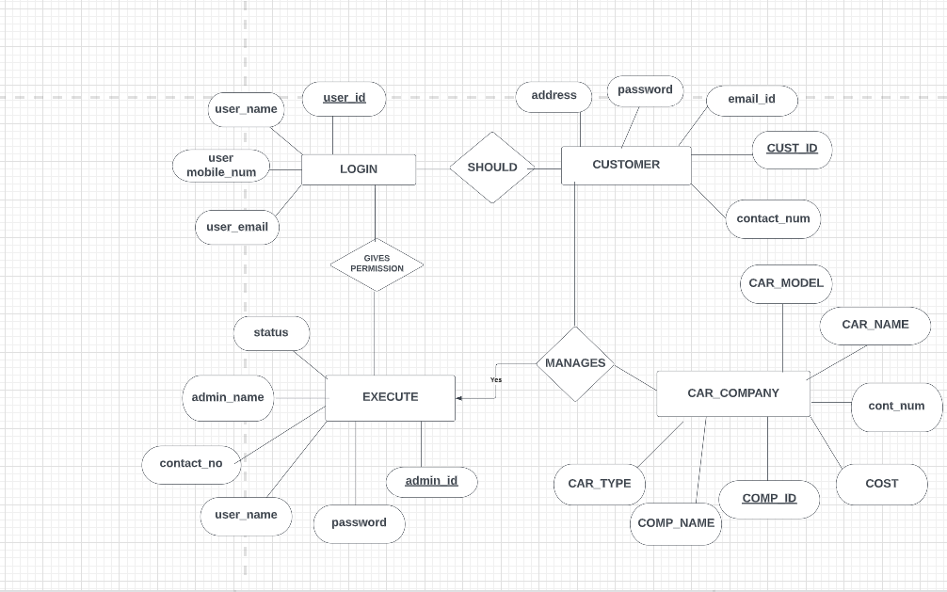

**TABLES THAT ARE PRESENT IN THE PROJECT:**

* login
* customer
* car company
* execute

**LOGIN Table:**

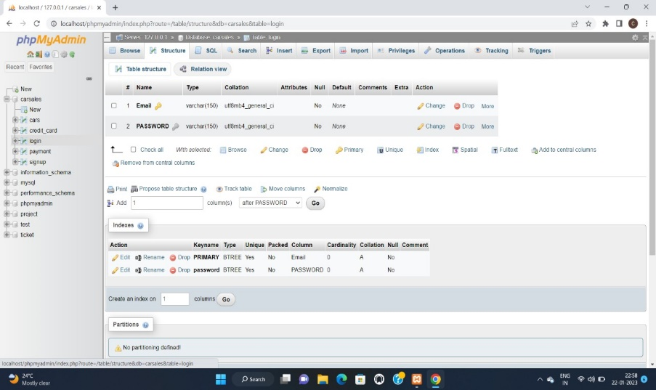

**CAR Table:**

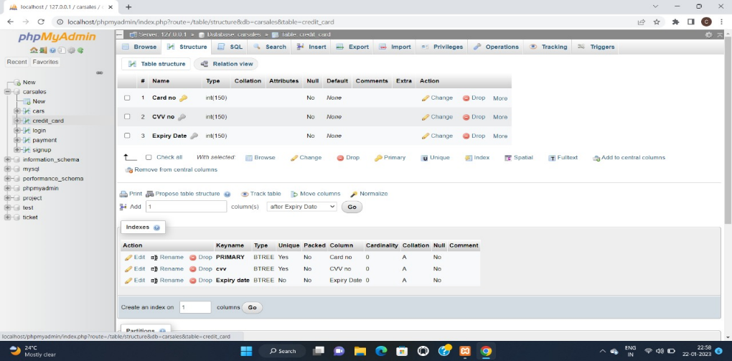

**CUSTOMER DETAILS Table:**

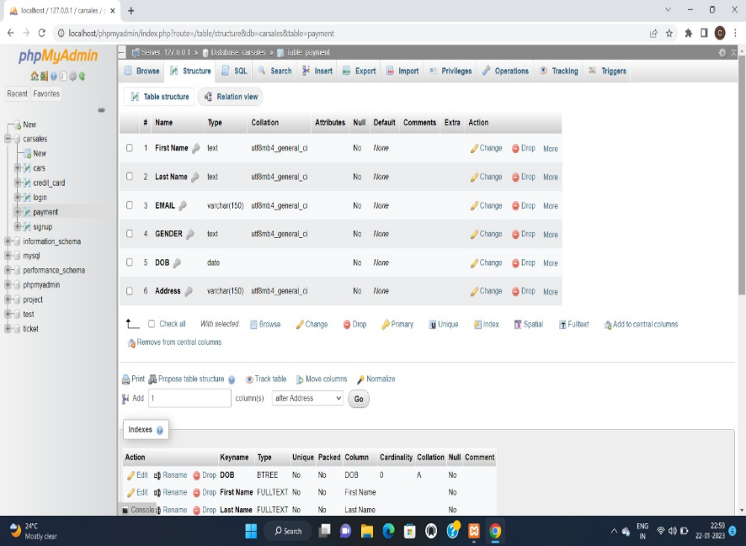

**EXCUTE Table:**

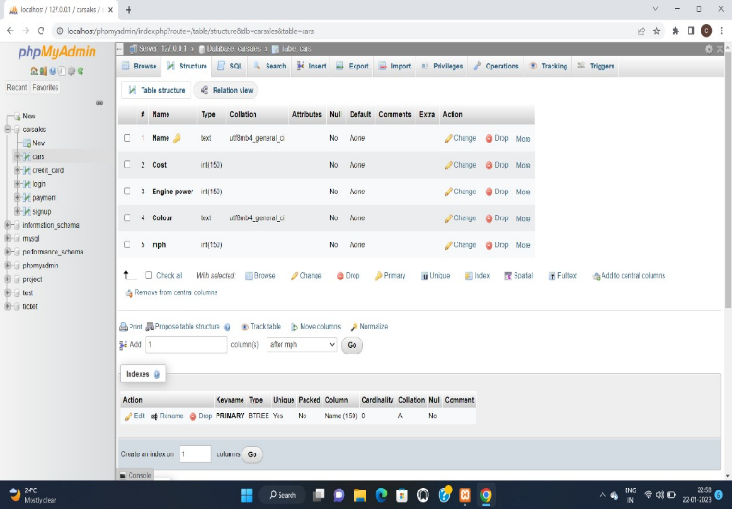

**WEBPAGE SCREENSHOTS FOR PROJECT:**

**Home page:**

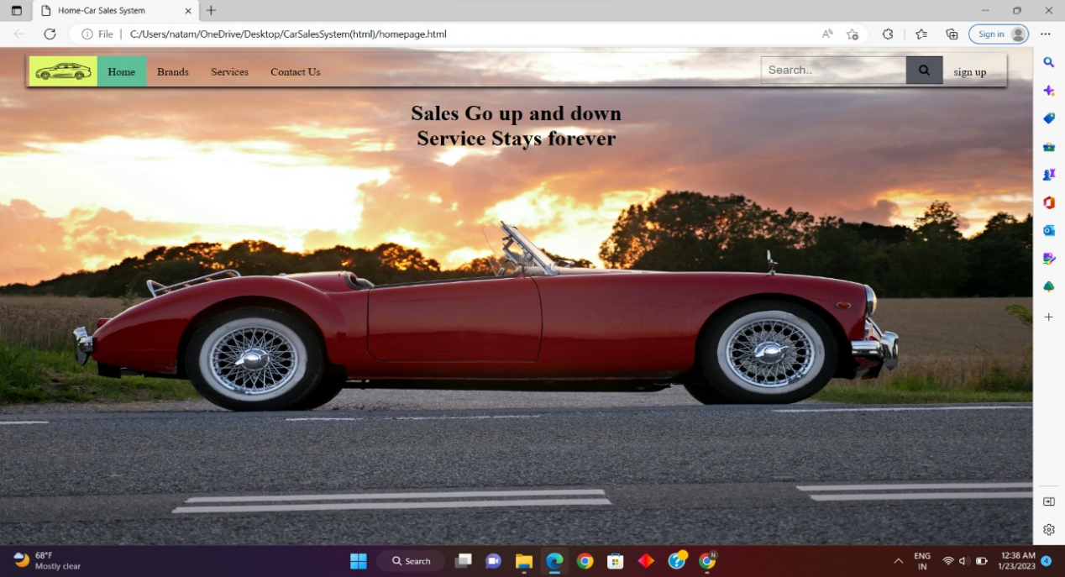

**Brands page:**

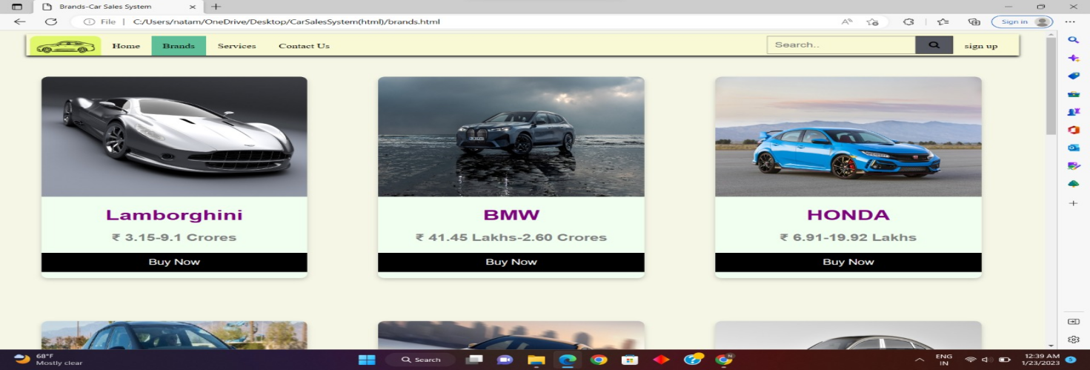

**Contact us :**

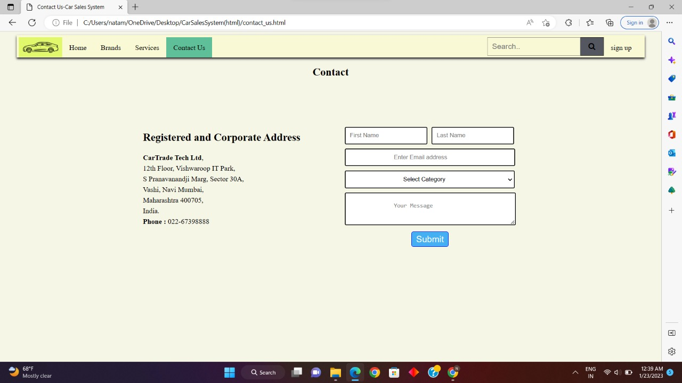

**login page:**

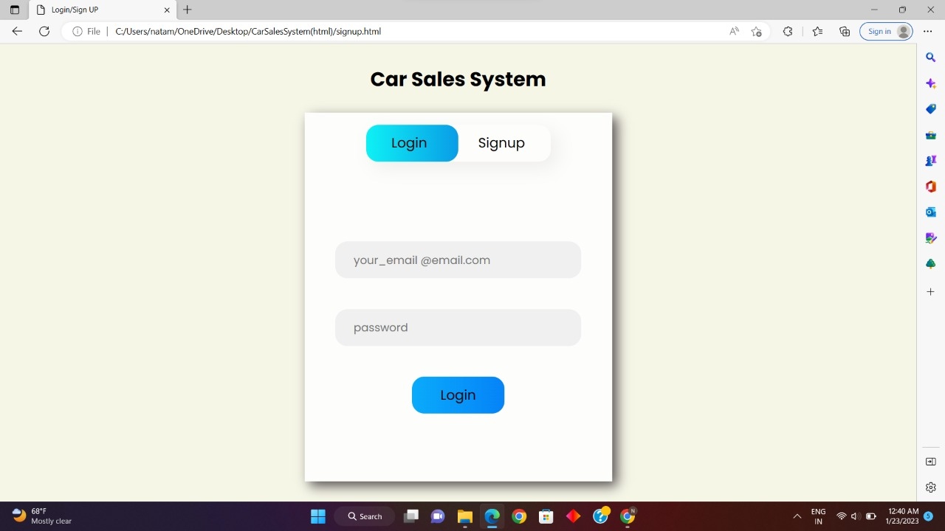

**payment:**

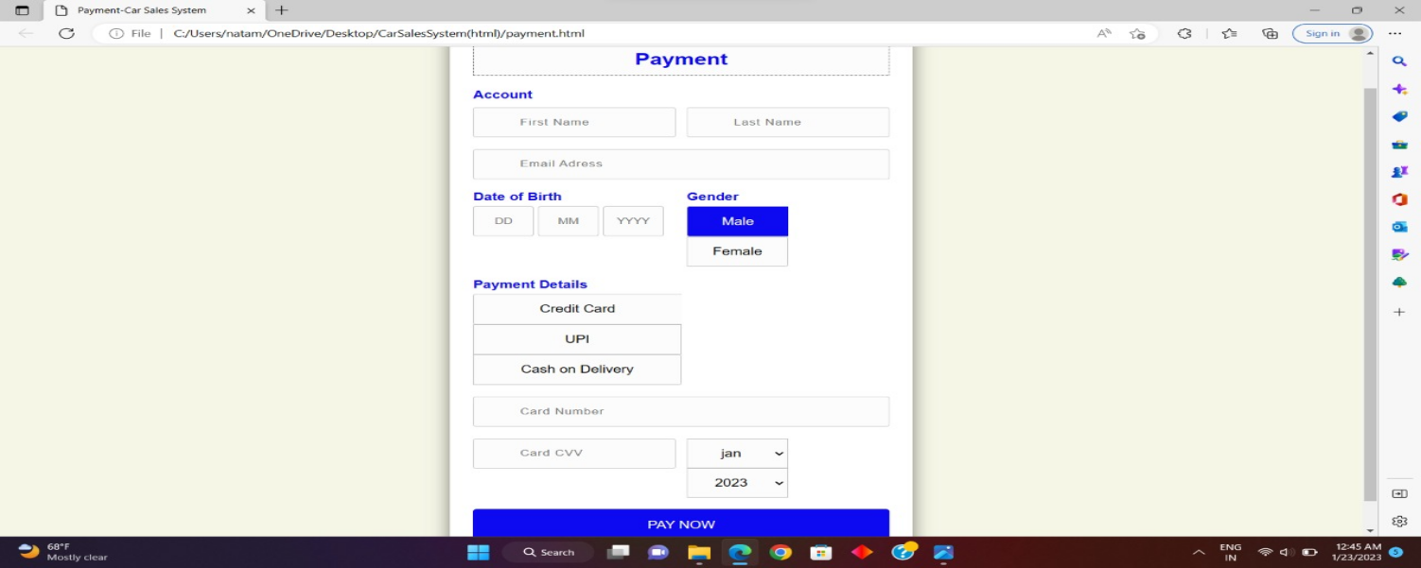

**Address:**

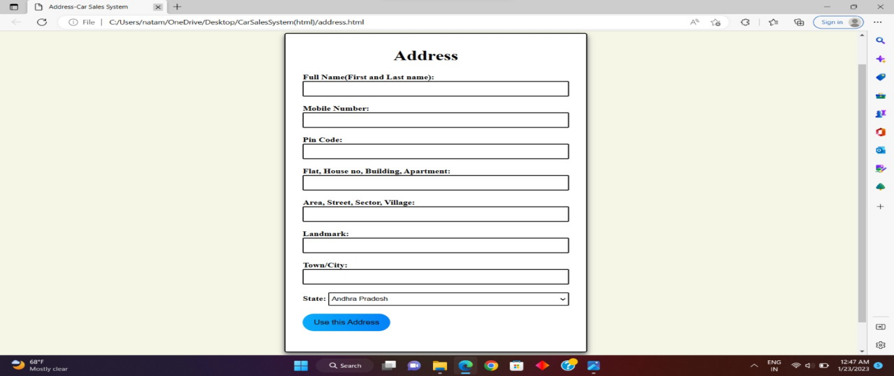

**Sign Up:**

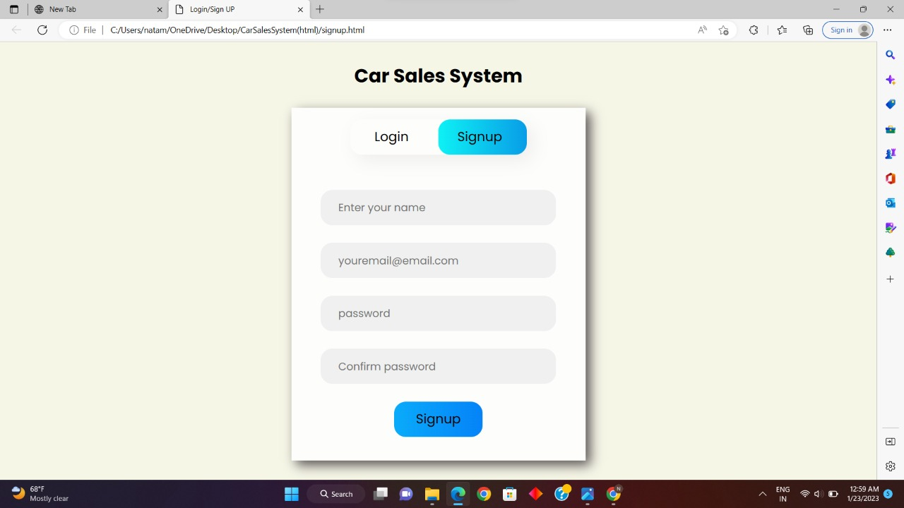

**Car company:**

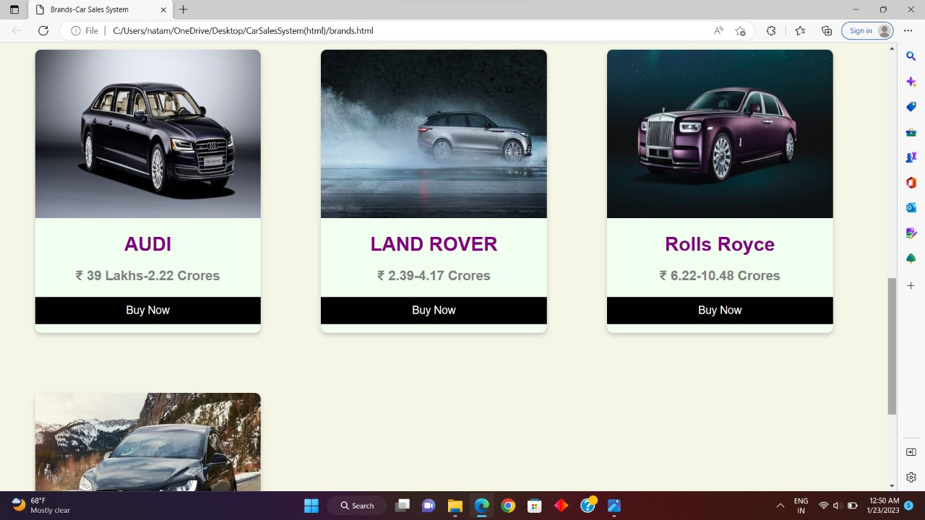

**Car models:**

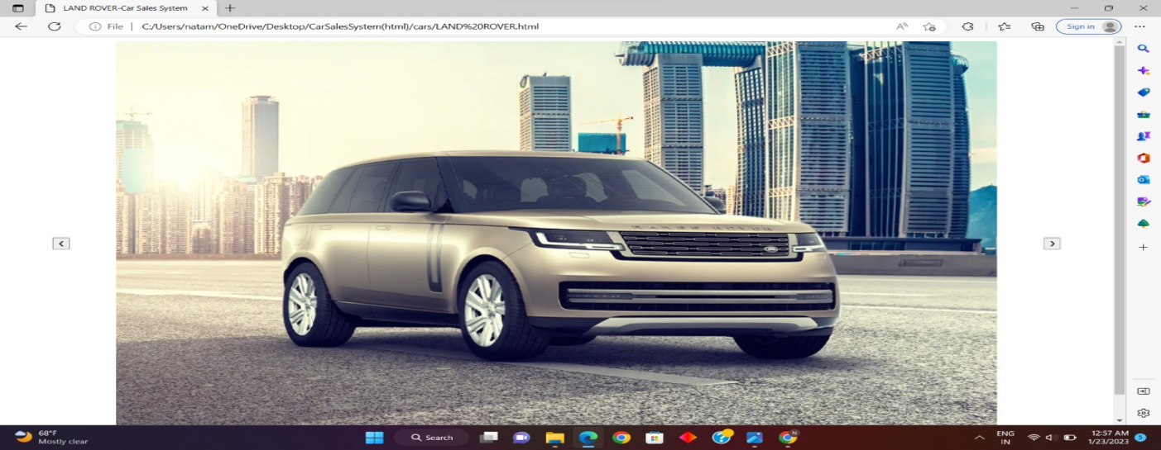

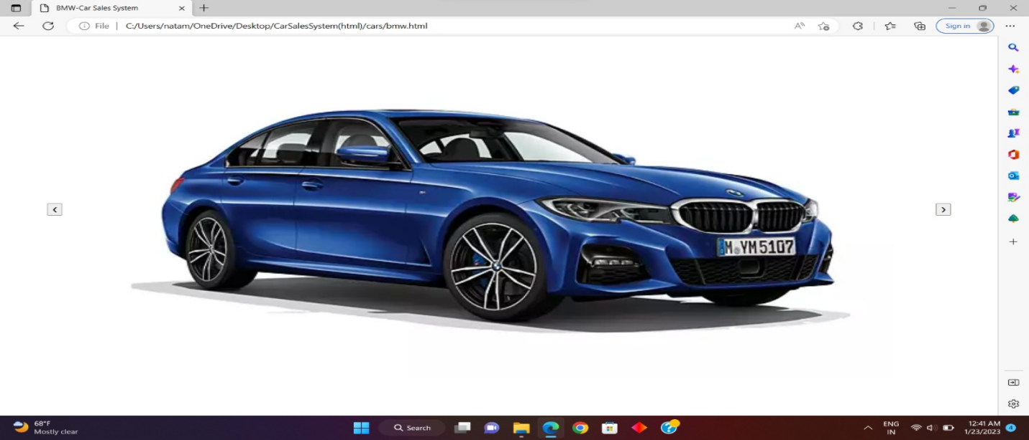

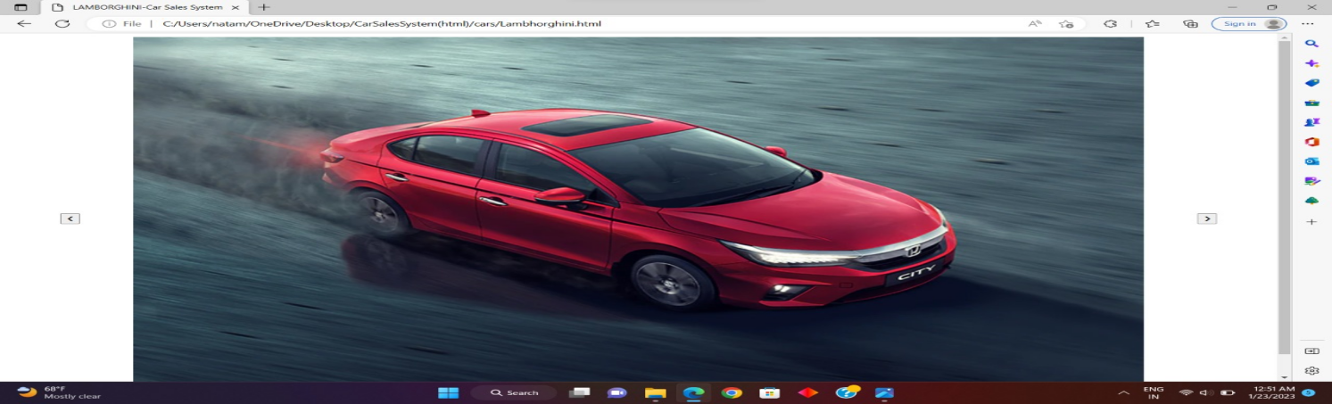

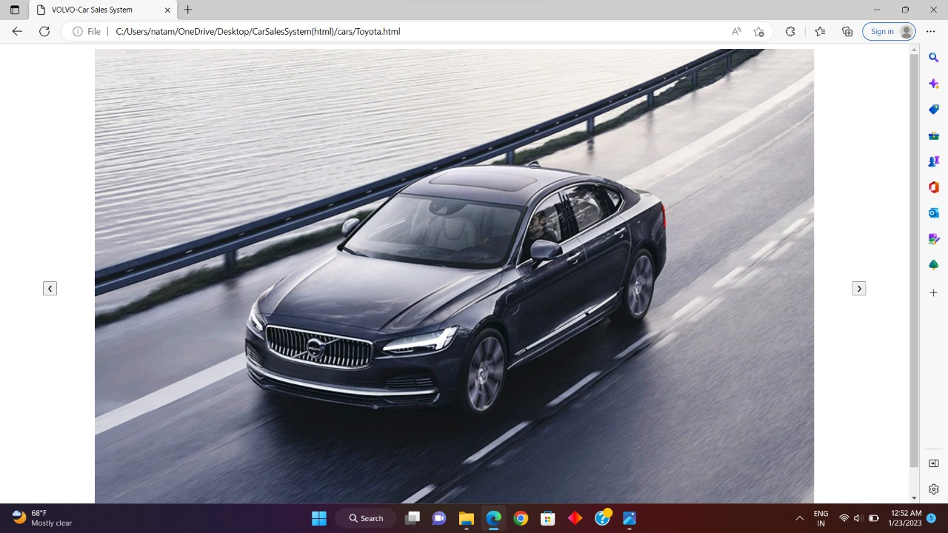

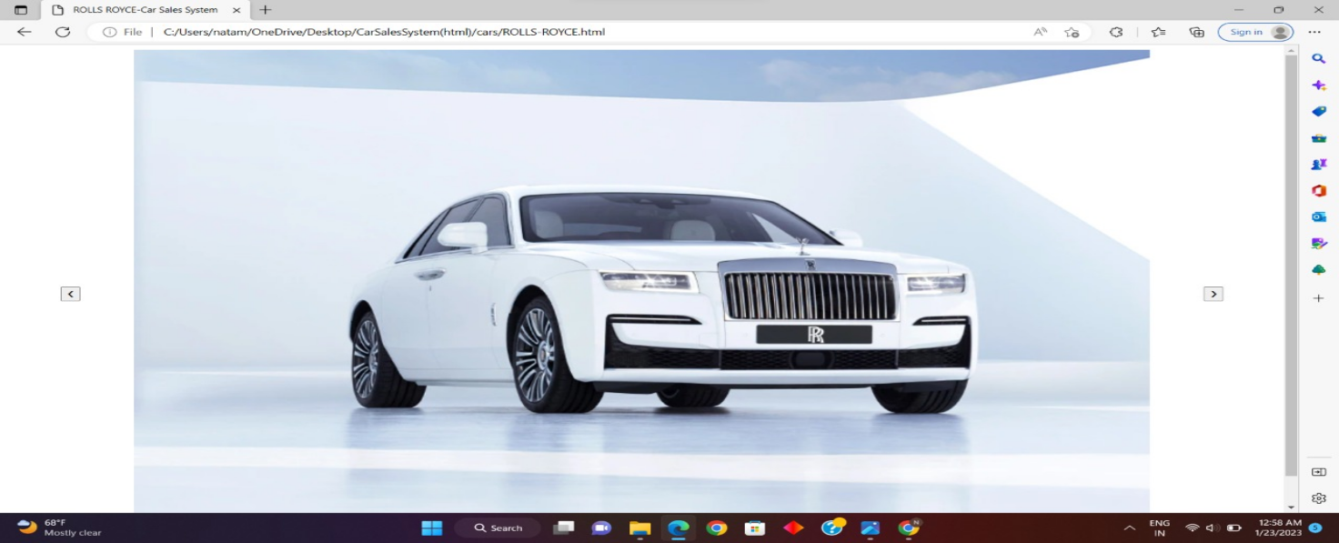

**Programming Code for Designing the Website Pages:**

**HomePage.html:**

<!DOCTYPE html>

<html>

<head>

<meta charset="UTF-8">

<meta name="viewport" content="width=device-width, initial-scale=1.0">

<link rel="stylesheet" href="style_homepage.css" />

<link rel="stylesheet" href="https://cdnjs.cloudflare.com/ajax/libs/font-awesome/4.7.0/css/font-awesome.min.css">

<title>Home-Car Sales System</title>

</head>

<body>

<nav>

<div>

<img src="file:///C:/Users/natam/OneDrive/Desktop/CarSalesSystem(html)/logo.png" alt="logo" class="nav-logo" />

<a href="file:///C:/Users/natam/OneDrive/Desktop/CarSalesSystem(html)/homepage.html"

style="background-color: rgb(94, 191, 152);">Home</a>

<a href="file:///C:/Users/natam/OneDrive/Desktop/CarSalesSystem(html)/brands.html">Brands</a>

<a href="file:///C:/Users/natam/OneDrive/Desktop/CarSalesSystem(html)/services.html">Services</a>

<a href="file:///C:/Users/natam/OneDrive/Desktop/CarSalesSystem(html)/contact_us.html">Contact Us</a>

</div>

<div>

<form class="example" action="action_page.php">

<input type="text" placeholder="Search.." name="search">

<button type="submit"><i class="fa fa-search"></i></button>

<a href="file:///C:/Users/natam/OneDrive/Desktop/CarSalesSystem(html)/signup.html">sign up</a>

</form>

</div>

</nav>

<h1 style="text-align:center"><b>Sales Go up and down <br>Service Stays forever</b></h1>

</body>

</html>

**Contact.html:**

<!DOCTYPE html>

<html>

<head>

<meta charset="UTF-8">

<meta name="viewport" content="width=device-width, initial-scale=1.0">

<link rel="stylesheet" href="style_contact_us.css" />

<link rel="stylesheet" href="https://cdnjs.cloudflare.com/ajax/libs/font-awesome/4.7.0/css/font-awesome.min.css">

<title>Contact Us-Car Sales System</title>

</head>

<body>

<nav>

<div>

<img src="file:///C:/Users/natam/OneDrive/Desktop/CarSalesSystem(html)/logo.png" alt="logo" class="nav-logo"/>

<a href="file:///C:/Users/natam/OneDrive/Desktop/CarSalesSystem(html)/homepage.html">Home</a>

<a href="file:///C:/Users/natam/OneDrive/Desktop/CarSalesSystem(html)/brands.html">Brands</a>

<a href="file:///C:/Users/natam/OneDrive/Desktop/CarSalesSystem(html)/services.html">Services</a>

<a href="file:///C:/Users/natam/OneDrive/Desktop/CarSalesSystem(html)/contact_us.html" style="background-color: rgb(94, 191, 152);">Contact Us</a>

</div>

<div>

<form class="example" action="action_page.php">

<input type="text" placeholder="Search.." name="search">

<button type="submit"><i class="fa fa-search"></i></button>

<a href="file:///C:/Users/natam/OneDrive/Desktop/CarSalesSystem(html)/signup.html">sign up</a>

</form>

</div>

</nav>

<section>

<div>

<div class="row justify-content-center pb-2 mb-4">

<div>

<h2>

<center>Contact</center>

</h2>

</div>

</div>

<div class="contact-container">

<div class="contact-details-form">

<div class="contact-details">

<h2><strong>Registered and Corporate Address</strong></h2>

<p style="line-height: 24px;"><strong style="color: #000000">CarTrade Tech

Ltd</strong>,<br>12th Floor, Vishwaroop IT Park,<br>S Pranavanandji Marg, Sector

30A,<br>Vashi, Navi Mumbai, <br>Maharashtra 400705,<br> India. <br><b>Phone :</b>

022-67398888</p>

</div>

<div>

<form>

<div class="contact-form-name">

<div><input type="text" placeholder="First Name"></div>

<div> <input type="text" placeholder="Last Name"></div>

</div>

<div class="contact-form-mail"><input type="email" placeholder="Enter Email address"></div>

<div class="contact-form-category">

<select>

<option value="">Select Category</option>

<option value="Customer enquiry">Customer enquiry</option>

<option value="Career enquiry">Career enquiry</option>

<option value="Auction related">Auction related</option>

<option value="Other queries">Other queries</option>

</select>

</div>

<div class="contact-form-message"><textarea placeholder="Your Message" maxlength="500" ></textarea></div>

<button type="submit" class="submit-btn">Submit</button>

</form>

<div

style="display:none; background:rgba(0, 0, 0, 0.5); position:fixed; width:100%; height:100%; left:0; top:0; z-index:9;">

</div>

<div

style="display: none;height: 120px;left: 0%;margin:auto;position: fixed;top: 0%; right:0; bottom:0; max-width: 340px; width:90%; background:#ffffff;z-index: 99999999;">

<a></a>

<div style="max-width:400px;">

<p> Thank you for your interest.<br>We will contact you shortly. </p>

</div>

</div>

</div>

</div>

</div>

</div>

</section>

</body>

</html>

**SIGN_UP.HTML:**

<!DOCTYPE html>

<html lang="en">

<head>

<meta charset="UTF-8">

<meta name="viewport"

content="width=device-width,

initial-scale=1.0">

<title>Login/Sign UP</title>

<link rel="stylesheet"

href="style_signup.css">

</head>

<body>

<header>

<h1 class="heading">Car Sales System</h1>

</header>

<div class="container">

<div class="slider"></div>

<div class="btn">

<button class="login">Login</button>

<button class="signup">Signup</button>

</div>

<div class="form-section">

<div class="login-box">

<input type="email"

class="email ele"

placeholder="your_email @email.com">

<input type="password"

class="password ele"

placeholder="password">

<button class="clkbtn">Login</button>

</div>

<div class="signup-box">

<input type="text"

class="name ele"

placeholder="Enter your name">

<input type="email"

class="email ele"

placeholder="youremail@email.com">

<input type="password"

class="password ele"

placeholder="password">

<input type="password"

class="password ele"

placeholder="Confirm password">

<button class="clkbtn">Signup</button>

</div>

</div>

</div>

<script src="index.js"></script>

</body>

</html>

**PAYMENT.HTML:**

<!DOCTYPE html>

<html lang="en">

<head>

<meta charset="UTF-8">

<meta name="viewport" content="width=device-width, initial-scale=1.0">

<title>Payment-Car Sales System</title>

<link rel="stylesheet" href="style_payment.css">

</head>

<body>

<div class="wrapper">

<h2>Payment</h2>

<form method="POST">

<h4>Account</h4>

<div class="input-group">

<div class="input-box">

<input type="text" placeholder="First Name" required class="name">

<i></i>

</div>

<div class="input-box">

<input type="text" placeholder="Last Name" required class="name">

<i></i>

</div>

</div>

<div class="input-group">

<div class="input-box">

<input type="email" placeholder="Email Adress" required class="name">

<i></i>

</div>

</div>

<div class="input-group">

<div class="input-box">

<h4> Date of Birth</h4>

<input type="text" placeholder="DD" class="dob">

<input type="text" placeholder="MM" class="dob">

<input type="text" placeholder="YYYY" class="dob">

</div>

<div class="input-box">

<h4> Gender</h4>

<input type="radio" id="b1" name="gendar" checked class="radio">

<label for="b1">Male</label>

<input type="radio" id="b2" name="gendar" class="radio">

<label for="b2">Female</label>

</div>

</div>

<div class="input-group">

<div class="input-box">

<h4>Payment Details</h4>

<input type="radio" name="pay" class="radio">

<label><span> Credit Card</span></label>

<input type="radio" name="pay" class="radio">

<label><span> UPI</span></label>

<input type="radio" name="pay" class="radio">

<label><span> Cash on Delivery</span></label>

</div>

</div>

<div class="input-group">

<div class="input-box">

<input type="tel" placeholder="Card Number" required class="name">

<i></i>

</div>

</div>

<div class="input-group">

<div class="input-box">

<input type="tel" placeholder="Card CVV" required class="name">

<i></i>

</div>

<div class="input-box">

<select>

<option>jan</option>

<option>feb</option>

<option>mar</option>

<option>apr</option>

<option>may</option>

<option>jun</option>

<option>jul</option>

<option>aug</option>

<option>sep</option>

<option>oct</option>

<option>nov</option>

<option>dec</option>

</select>

<select>

<option>2023</option>

<option>2024</option>

<option>2025</option>

<option>2026</option>

<option>2027</option>

<option>2028</option>

<option>2029</option>

<option>2030</option>

</select>

</div>

</div>

<div class="input-group">

<div class="input-box">

<button type="submit">PAY NOW</button>

</div>

</div>

</form>

</div>

</body>

</html>

**PAYMENT.HTML :**

<!DOCTYPE html>

<html>

<head>

<meta charset="UTF-8">

<meta name="viewport" content="width=device-width, initial-scale=1.0">

<link rel="stylesheet" href="style_services.css" />

<link rel="stylesheet" href="https://cdnjs.cloudflare.com/ajax/libs/font-awesome/4.7.0/css/font-awesome.min.css">

<title>Services-Car Sales System</title>

</head>

<body>

<nav>

<section>

<img src="file:///C:/Users/natam/OneDrive/Desktop/CarSalesSystem(html)/logo.png" alt="logo" class="nav-logo"/>

<a href="file:///C:/Users/natam/OneDrive/Desktop/CarSalesSystem(html)/homepage.html">Home</a>

<a href="file:///C:/Users/natam/OneDrive/Desktop/CarSalesSystem(html)/brands.html">Brands</a>

<a href="file:///C:/Users/natam/OneDrive/Desktop/CarSalesSystem(html)/services.html"

style="background-color: rgb(94, 191, 152);">Services</a>

<a href="file:///C:/Users/natam/OneDrive/Desktop/CarSalesSystem(html)/contact_us.html">Contact Us</a>

</section>

<section>

<form class="example" action="action_page.php">

<input type="text" placeholder="Search.." name="search">

<button type="submit"><i class="fa fa-search"></i></button>

<a href="file:///C:/Users/natam/OneDrive/Desktop/CarSalesSystem(html)/signup.html">sign up</a>

</form>

</section>

</nav>

<h1>

<center>Service the car,<br> serve the customers</center>

</h1>

<div class="dive">

<div class="service">

<h3>New Car OEM Solutions</h3>

<p style="font-size:large">OEMs can showcase their brands, products and services to the millions of customers that

visit our platforms. Our wide consumer reach allows us to help OEMs build and strengthen their brands. We also

provide OEMs with consumer insights and data-driven solutions, to help them build their digital marketing

strategies.</p>

</div>

<div class="service">

<h3>New Car Dealer Solutions</h3>

<p style="font-size:large">Millions of customers visit each month to research and buy a new car. We provide these

customers content and research tools such as car reviews, accurate on road prices, car specifications, car

images, car finance offers, and more. Customers can express interest in a new car and we connect them to the

right new car dealer. New cars dealers can get access to these customers and reach out to them and thus maximise

their sales</p>

</div>

</div>

</body>

**Login.html:**

<!DOCTYPE html>

<html>

<head>

<meta charset="UTF-8">

<meta name="viewport" content="width=device-width, initial-scale=1.0">

<link rel="stylesheet" href="style_services.css" />

<link rel="stylesheet" href="https://cdnjs.cloudflare.com/ajax/libs/font-awesome/4.7.0/css/font-awesome.min.css">

<title>Services-Car Sales System</title>

</head>

<body>

<nav>

<section>

<img src="file:///C:/Users/natam/OneDrive/Desktop/CarSalesSystem(html)/logo.png" alt="logo" class="nav-logo"/>

<a href="file:///C:/Users/natam/OneDrive/Desktop/CarSalesSystem(html)/homepage.html">Home</a>

<a href="file:///C:/Users/natam/OneDrive/Desktop/CarSalesSystem(html)/brands.html">Brands</a>

<a href="file:///C:/Users/natam/OneDrive/Desktop/CarSalesSystem(html)/services.html"

style="background-color: rgb(94, 191, 152);">Services</a>

<a href="file:///C:/Users/natam/OneDrive/Desktop/CarSalesSystem(html)/contact_us.html">Contact Us</a>

</section>

<section>

<form class="example" action="action_page.php">

<input type="text" placeholder="Search.." name="search">

<button type="submit"><i class="fa fa-search"></i></button>

<a href="file:///C:/Users/natam/OneDrive/Desktop/CarSalesSystem(html)/signup.html">sign up</a>

</form>

</section>

</nav>

<h1>

<center>Service the car,<br> serve the customers</center>

</h1>

<div class="dive">

<div class="service">

<h3>New Car OEM Solutions</h3>

<p style="font-size:large">OEMs can showcase their brands, products and services to the millions of customers that

visit our platforms. Our wide consumer reach allows us to help OEMs build and strengthen their brands. We also

provide OEMs with consumer insights and data-driven solutions, to help them build their digital marketing

strategies.</p>

</div>

<div class="service">

<h3>New Car Dealer Solutions</h3>

<p style="font-size:large">Millions of customers visit each month to research and buy a new car. We provide these

customers content and research tools such as car reviews, accurate on road prices, car specifications, car

images, car finance offers, and more. Customers can express interest in a new car and we connect them to the

right new car dealer. New cars dealers can get access to these customers and reach out to them and thus maximise

their sales</p>

</div>

</div>

</body>

</html>

**ADDRESS.HTML:**

<!DOCTYPE html>

<html lang="en">

<head>

<meta charset="UTF-8">

<meta name="viewport" content="width=device-width,

initial-scale=1.0">

<title>Address-Car Sales System</title>

<link rel="stylesheet" href="style_address.css">

</head>

<body>

<div>

<h1>Address</h1>

<label type="Name"><b>Full Name(First and Last name):</b></label><br>

<input type="text" place holder=""><br><br>

<label type="Phone Number"><b>Mobile Number:</b></label><br>

<input type="text" place holder=""><br><br>

<label type="text"><b>Pin Code:</b></label><br>

<input type="text" place holder="6 digits[0-9]Pin code"><br><br>

<label type="text"><b>Flat, House no, Building, Apartment:</b></label><br>

<input type="text" place holder=""><br><br>

<label type="text"><b>Area, Street, Sector, Village:</b></label><br>

<input type="text" place holder=""><br><br>

<label type="text"><b>Landmark:</b></label><br>

<input type="text" place holder="E.g. near appolo hospital"><br><br>

<label type="text"><b>Town/City:</b></label>

<input type="text" place holder=""><br><br>

<label><b>State:</b></label>

<select>

<option value="Andhra Pradesh">Andhra Pradesh</option>

<option value="Karnataka">Karnataka</option>

<option value="Kerala">Kerala</option>

<option value="Tamil Nadu">Tamil Nadu</option>

<option value="Telangana">Telangana</option>

</select></br><br>

<button>Use this Address</button>

</div>

</body>

**BRAND.HTML:**

<!DOCTYPE html>

<html>

<head>

<meta charset="UTF-8">

<meta name="viewport" content="width=device-width, initial-scale=1.0">

<link rel="stylesheet" href="style_brands.css" />

<link rel="stylesheet" href="https://cdnjs.cloudflare.com/ajax/libs/font-awesome/4.7.0/css/font-awesome.min.css">

<title>Brands-Car Sales System</title>

</head>

<body>

<nav>

<section>

<img src="file:///C:/Users/natam/OneDrive/Desktop/CarSalesSystem(html)/logo.png" alt="logo" class="nav-logo" />

<a href="file:///C:/Users/natam/OneDrive/Desktop/CarSalesSystem(html)/homepage.html">Home</a>

<a href="file:///C:/Users/natam/OneDrive/Desktop/CarSalesSystem(html)/brands.html"

style="background-color: rgb(94, 191, 152);">Brands</a>

<a href="file:///C:/Users/natam/OneDrive/Desktop/CarSalesSystem(html)/services.html">Services</a>

<a href="file:///C:/Users/natam/OneDrive/Desktop/CarSalesSystem(html)/contact_us.html">Contact Us</a>

</section>

<section>

<form class="example" action="action_page.php">

<input type="text" placeholder="Search.." name="search">

<button type="submit"><i class="fa fa-search"></i></button>

<a href="file:///C:/Users/natam/OneDrive/Desktop/CarSalesSystem(html)/signup.html">sign up</a>

</form>

</section>

</nav>

<br>

<div class="card">

<a href="file:///C:/Users/natam/OneDrive/Desktop/CarSalesSystem(html)/cars/Lambhorghini.html">

<img src="https://th.bing.com/th/id/R.26c1f38423423d41ed74004479cb2095?rik=KzvrST5OymTGsQ&riu=http%3a%2f%2f1.bp.blogspot.com%2f-cyUpufR6eYo%2fTwCrSmzNFSI%2fAAAAAAAAALI%2fCU1NLcZqUl8%2fs1600%2fSport%2bcars%2bwallpapers%2bfree%2bdownload.jpg&ehk=t3tOnTws1BrWWXXwKjEkb7upz1mK9LZhLoLLVwziXEQ%3d&risl=&pid=ImgRaw&r=0"

alt="Lamborghini" />

<h1>Lamborghini</h1>

</a>

<p class="price"><b>&#8377 3.15-9.1 Crores</b></p>

<p><button>Buy Now</button></p>

</div>

<div class="card">

<a href="file:///C:/Users/natam/OneDrive/Desktop/CarSalesSystem(html)/cars/bmw.html">

<img

src="https://www.globalbrandsmagazine.com/wp-content/uploads/2022/01/P90447387_lowRes_the-new-bmw-ix-m60-0.jpg"

alt="BMW" />

<h1>BMW</h1>

</a>

<p class="price"><b>&#8377 41.45 Lakhs-2.60 Crores</b></p>

<p><button>Buy Now</button></p>

</div>

<div class="card">

<a href="file:///C:/Users/natam/OneDrive/Desktop/CarSalesSystem(html)/cars/HONDA.html">

<img

src="https://www.globalbrandsmagazine.com/wp-content/uploads/2020/09/2021-Honda-Civic-Type-R-014-1200x800-1-1.jpg"

alt="HONDA" />

<h1>HONDA</h1>

</a>

<p class="price"><b>&#8377 6.91-19.92 Lakhs</b></p>

<p><button>Buy Now</button></p>

</div>

<div class="card">

<a href="file:///C:/Users/natam/OneDrive/Desktop/CarSalesSystem(html)/cars/Toyota.html">

<img src="https://www.globalbrandsmagazine.com/wp-content/uploads/2016/03/Toyota-mirai.jpg" alt="Toyota" />

<h1>Toyota</h1>

</a>

<p class="price"><b>&#8377 6.59 Lakhs-2.1 Crores</b></p>

<p><button>Buy Now</button></p>

</div>

<div class="card">

<a href="file:///C:/Users/natam/OneDrive/Desktop/CarSalesSystem(html)/cars/FORD.html">

<img src="https://www.globalbrandsmagazine.com/wp-content/uploads/2013/12/fcs14_pg_021_ext_enl.jpg" alt="FORD" />

<h1>FORD</h1>

</a>

<p class="price"><b>&#8377 5.91-8.36 Lakhs</b></p>

<p><button>Buy Now</button></p>

</div>

<div class="card">

<a href="file:///C:/Users/natam/OneDrive/Desktop/CarSalesSystem(html)/cars/Volvo.html">

<img src="https://www.globalbrandsmagazine.com/wp-content/uploads/2016/11/Volvo-car.jpg" alt="VOLVO" />

<h1>VOLVO</h1>

</a>

<p class="price"><b>&#8377 45.9-96.5 Lakhs</b></p>

<p><button>Buy Now</button></p>

</div>

<div class="card">

<a href="file:///C:/Users/natam/OneDrive/Desktop/CarSalesSystem(html)/cars/AUDI.html">

<img src="https://www.globalbrandsmagazine.com/wp-content/uploads/2016/04/Audia8l.jpg" alt="AUDI" />

<h1>AUDI</h1>

</a>

<p class="price"><b>&#8377 39 Lakhs-2.22 Crores</b></p>

<p><button>Buy Now</button></p>

</div>

<div class="card">

<a href="file:///C:/Users/natam/OneDrive/Desktop/CarSalesSystem(html)/cars/LAND ROVER.html">

<img src="https://www.globalbrandsmagazine.com/wp-content/uploads/2020/09/Land-Rover.jpg" alt="LAND ROVER" />

<h1>LAND ROVER</h1>

</a>

<p class="price"><b>&#8377 2.39-4.17 Crores</b></p>

<p><button>Buy Now</button></p>

</div>

<div class="card">

<a href="file:///C:/Users/natam/OneDrive/Desktop/CarSalesSystem(html)/cars/ROLLS-ROYCE.html">

<img

src="https://www.rolls-roycemotorcars.com/content/dam/rrmc/marketUK/rollsroycemotorcars_com/3-3-phantom-ewb/page-properties/rolls-royce-phantom-swb-discover-hero-d.jpg"

alt="Rolls Royce" />

<h1>Rolls Royce</h1>

</a>

<p class="price"><b>&#8377 6.22-10.48 Crores</b></p>

<p><button>Buy Now</button></p>

</div>

<div class="card">

<a href="file:///C:/Users/natam/OneDrive/Desktop/CarSalesSystem(html)/cars/Tesla.html">

<img src="https://www.globalbrandsmagazine.com/wp-content/uploads/2020/12/2020-Tesla-Model-X-1.jpg" alt="Tesla" />

<h1>Tesla</h1>

</a>

<p class="price"><b>&#8377 70 Lakhs</b></p>

<p><button>Buy Now</button></p>

</div>

</body>

</html>

**RESULT:**

All the cases mentioned above are passed . No defects,bugs,errors encountered, and also all are working properly without any Problems.

**CONCLUSION :**

Working on the project was an excellent experience. It helped us to understand the importance of planning, designing and implementation so far we have learnt in our theory books. It helped us unleashing our creativity while working in a team. It also realized the importance of team working, communication as a part of this project.

The project was successfully completed after a lot of efforts and work hours. This project underwent number of compiling, debugging, removing errors, making it bug free, adding more facilities in Web car sales Management System and interactivity making it more reliable and useful.

The entire project has been developed and deployed as per the requirements stated by the user. It is found to be bug free as per the testing standards that are implemented.

Finally, we like to conclude that we put all our efforts throughout the development of our project and tried to fulfill most of the requirements of the user.

**REFERENCES / BIBLOGRAPHY :**

* PHP MySQL Website Programming: Problem - Design – Solution byChrisLea, Mike Buzzard, Dilip Thomas , Jessey White-Cinis
* Beginning PHP5, Apache, and MySQL Web Development (Programmer toProgrammer) by Elizabeth Naramore
* MySQL/PHP Database Applications, 2nd Edition by Brad Bulger
* 4.How to Do Everything with PHP and MySQL by Vikram Vaswani